**Group assignment on SDG7 Rural electrification**

The aim in this group assignment is that you shall *conceptually* move the *complex problem* (wicked problem), Fig. 1, of rural electrification fulfilling SDG 7: “affordable, reliable, sustainable and modern energy” into a *complicated problem*, which can be tackled with modern optimization methods. However, you will not be asked to solve the complicated optimization problem you have formulated.

Following your individual assignment on SDG 7: rural electrification, your group shall work on setting up an optimization problem of the following type:

Minimize

a function (with your own selection of variables)

subject to constraints (expressed with respect to):

* Affordable
* Reliable
* Sustainable
* Modern
* Other Sustainable Development Goals (SDGs), and/or
* Intersecting Social Factors.

We propose two main alternatives on how to organize this work:

1. Aim at designing your ideal optimization problem for your selected rural setting by taking inspiration from the references that you have read, or
2. Start from the optimization problems in one of the references and try to modify that one by adding more design variables and/or constraints.

For alternative 2, you should start to agree on which reference you should use as a starting point, as you surely have selected different references.

Irrespective of the selected alternative above, we propose the following step-by-step procedure (see the proposed template on the last page):

* Describe your rural electrification system and location.
* What should the optimization problem (function to be minimized and constraints) include to be able to have clear SDG *synergies*? List SDGs that may be in synergy with SDG 7 and describe briefly how you have selected those SDGs.
* What possible SDG *trade-offs* have you identified? Describe how you would trade-off, i.e., prioritize, between the different SDGs in conflict.
* Finally, discuss what challenges you most likely will face when trying to solve your optimization problem and what you should do to handle those challenges.

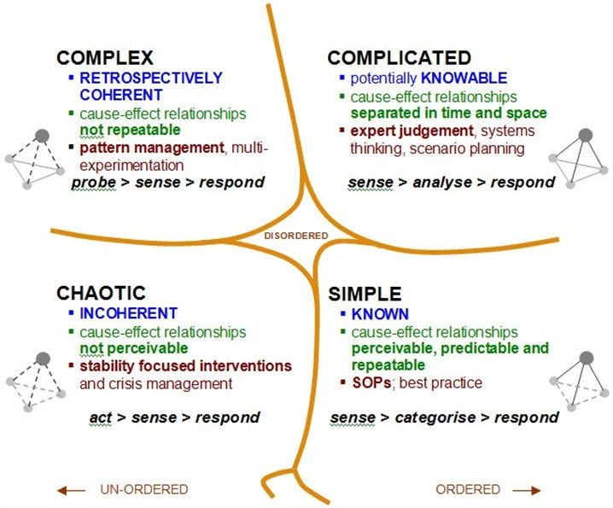

Figure 1: Cynefin framework (<https://medium.com/10x-curiosity/know-your-domain-the-cynefin-framework-dc28648558f1>)

Table 1: Suggested seminar schedule for SDG 7: Rural electrification.

|  |  |
| --- | --- |
| **Duration (minutes)** | **Activity** |
| 5 | **Quick check-in**   * Is anything unclear in the instructions about what to do during the seminar. * Select a new chairperson and secretary (can be the same person). * Remember the KTH Code of Conduct. |
| 70 (incl. 15 min break) | **In-group discussion**   * Documentation of the discussion on shall be done by the secretary in a simple Word file or PPT. * The chairperson (or secretary) should invite all members to contribute to the development of the cost function and constraints/conditions. |
| 25 | **Group-to-group whiteboard presentations**   * Summarize your optimization problem (cost function and constraints) on a whiteboard in the classroom. It should not take more than 5 minutes to write it on the whiteboard. * Orally present the optimization problem to another group for note more than 10 minutes including questions from the other group. * Switch groups so that your group listen to the other group’s presentation. |
| 5 | **Whole class wrap-up**   * How did that go? * What are the three key takeaways from this session? * Any other comments? |

*This is the page that you shall submit on Canvas!*

**Summary of the optimization of a rural electrification system**

We want to optimize:

[Describe your rural electrification system here]

with the following variables (metrics):

* ?
* ?
* ?

subject to the following constraints (and thresholds):

* ?
* ?
* ?

This system is in synergy with the following SDGs:

* ?
* ?
* ?

and we need to trade-off with the following SDGs:

* ?
* ?
* ?

The challenges (and how to handle them) are:

* ?
* ?
* ?
* ?